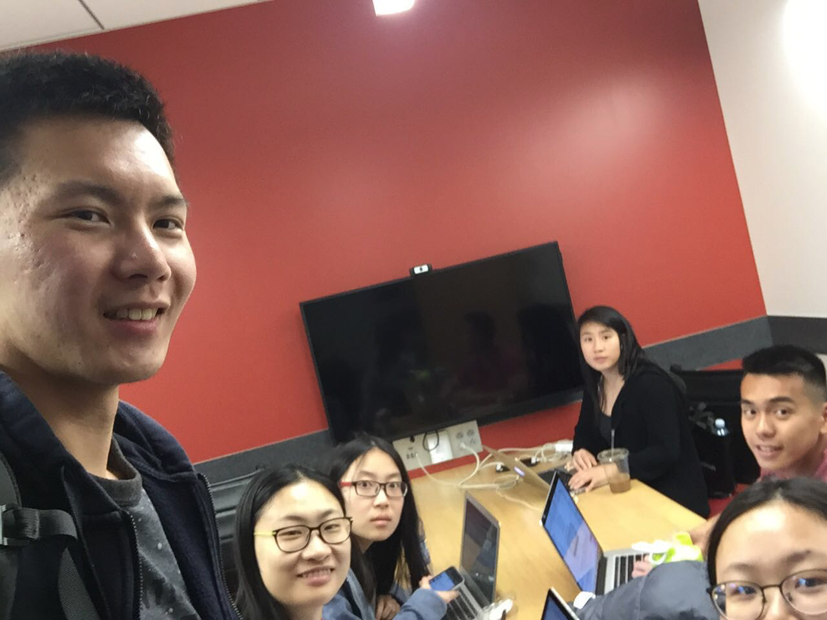

Allocated meeting time: April 19th, 5:00pm-6:00pm

Actual meeting time: April 19th, 5:00pm-6:00pm

Product owner: Professor Halfond, TAs, CPs

Scrum master: Gong Chen

Team members: Lingyi Li, Joann Lin, Peixuan Liu, Ryan To, Tuling Zhao

Scrum summary:

We were working on our new tasks assigned in this sprint.

1. What have you accomplished since the last meeting?
2. Are there any obstacles in the way of meeting your goal?
3. What will you accomplish before the next meeting?

Gong Chen:

1. Displayed error message when not enough image found for random key words
2. The modification did not affect the application until I cleaned and built the project
3. Send error message to front end

Lingyi Li:

1. I finished the review document
2. None
3. I will start to write the second section in the sprint process report

Joann Lin:

1. I have fixed save collage functionality so the saved collage stays in the History bar even when it is clicked. I have also added the buttons for deletion.
2. No obstacles
3. I will merge my code with the master branch. I will implement back-end functionality for saved collage deletion.

Peixuan Liu:

1. Added more white-box tests for Server.java
2. No
3. Split Server.java into smaller classes and functions

Ryan To:

1. I have added different blackbox testing options on a different branch and merged it with master
2. Waiting for Gong to finish “insufficient number of images found” error on the backend
3. I will continue to implement blackbox tests for multiple users, signup and “insufficient number of images found” error on the frontend.

Tuling Zhao:

1. Fixed collage display position
2. None
3. I will add requirement of must selecting one filter option on main.jsp (since we have “No Filter” option)